1. select count (\*) FROM Customers where country='Germany'; 11
2. select count (\*) FROM Customers where ContactName LIKE '%e %'; 21
3. insert into customers (CustomerName, ContactName, Address, City, PostalCode, Country) values ('tester', 'Nikolay Gahov', '1 street', 'Novosibirsk', '630000', 'Russia')

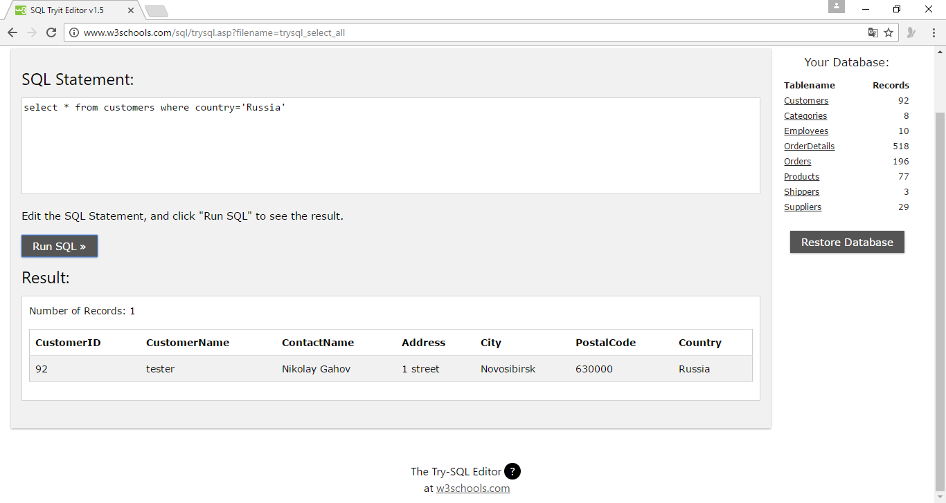

1. update customers set ContactName='Nikolay N. Gakhov' where CustomerId='92'

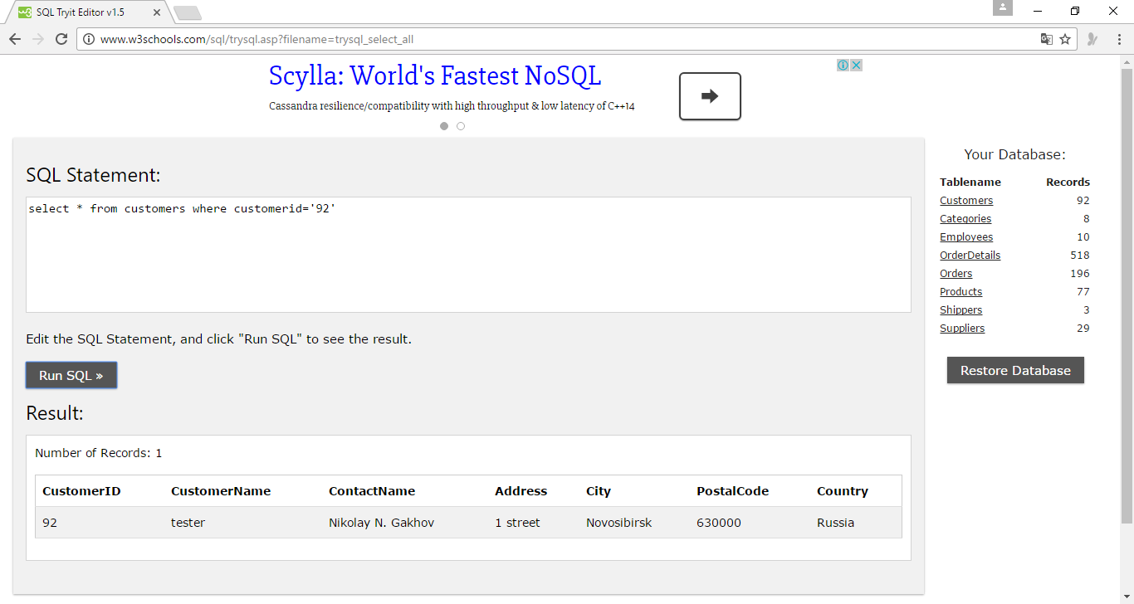

1. delete from customers where city='Nantes'

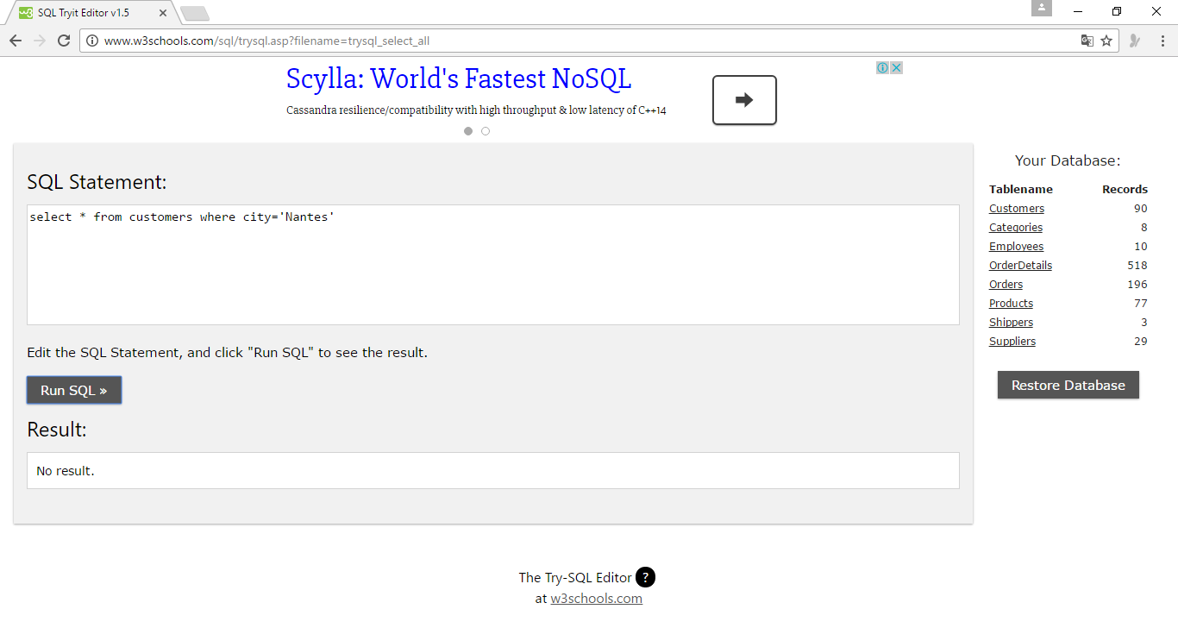

1. SELECT Customers.CustomerName, Orders.OrderID, Orders.EmployeeID

FROM Customers

INNER JOIN Orders

ON Customers.CustomerID=Orders.CustomerID

where Orders.EmployeeID=5

ORDER BY Customers.CustomerName;

